Shapes and Image Selection
Jeremiah (Jay) Case
SNHU
CS-330
Professor Iles
7/4/2026

Shapes and Image Selection
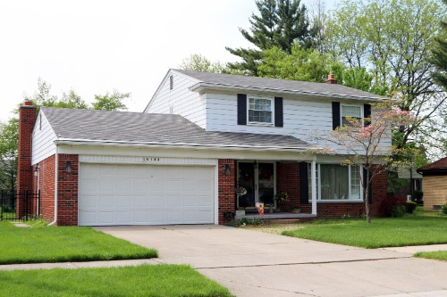
For this activity, I selected the image of the house with the attached garage. The major objects I would recreate are the house, garage, roof, chimney, and tree. The house and garage could be constructed using boxes, while the roof could be represented with prisms. The chimney could be created using boxes or cylinders. The driveway, sidewalk, and lawn could be modeled using planes. The tree would require multiple shapes, including a cylinder for the trunk and several spheres or cones for the foliage. A tapered cylinder could also be used to create a more realistic tree trunk.

The tree is the object that requires multiple shapes because a single primitive cannot accurately represent both the trunk and the canopy. To simplify the 3D scene, I would remove most of the background trees, avoid modeling individual roof shingles and window trim, and use flat planes with textures instead of creating detailed grass or brick patterns. These simplifications would preserve the overall appearance while making the project more efficient to develop, which is a common practice in 3D graphics modeling (Rightware, 2020).
References
Rightware. (2020, March 4). 6 seriously cool ways to use 3D computer graphics. https://rightware.com/blog/6-seriously-cool-ways-to-use-3d-computer-graphics/

